LANGLANDS LADIES’ OPEN TRI-AM

JULY 14th 2021

TEAMS OF THREE - £30 PER TEAM

TEE TIMES FROM 10.00 – 14.00

|  |  |
| --- | --- |
| HOME CLUB (s) |  |
| Name (member 1) |  |
| Name (member 2) |  |
| Name (member 3) |  |

|  |  |
| --- | --- |
| Preferred tee time range | *Will try to accommodate your preference but cannot guarantee* |
| 10.00 – 11.00 |  |
| 11.00 – 12.00 |  |
| 12.00 – 13.00 |  |
| 13.00 – 14.00 |  |

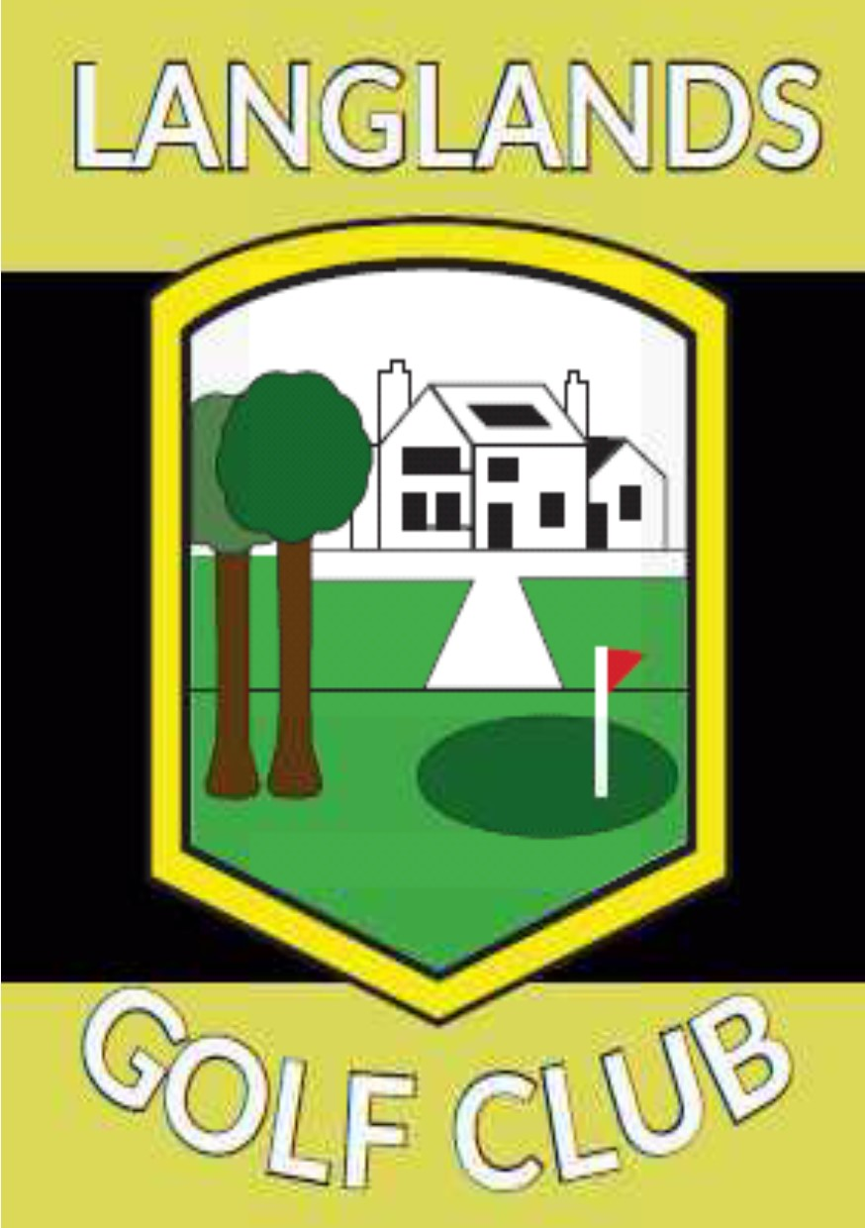

Please pay full team entry fee by bank transfer to :

Langlands Golf Club

Sort code: 800664 Account number: 00532136

*Please make sure you give your name as reference*

Closing date for entries and entry fees: 24.6.2021

Please return form by email to:

[langlands_golf@quinag.com](mailto:langlands_golf@quinag.com)

or by post to:

Ladies’ Match Secretary, Langlands Golf Club, Langlands Rd, East Kilbride, Glasgow G75 9DW

Many thanks and look forward to seeing you on 14th July.