LANGLANDS GOLF CLUB

LADIES’ OPEN TRI-AM - 30th June 2024

TEAMS OF THREE - £30 PER TEAM (individual entries will

be accepted and you will be allocated a team) – maximum individual handicap – 36

TEE TIMES FROM 10.00 – 14.30

|  |  |
| --- | --- |
| HOME CLUB(s) |  |
| Name (1), CDH & contact details |  |
| Name (2), CDH & contact details |  |
| Name (3), CDH & contact details |  |

|  |  |
| --- | --- |
| Preferred tee time range | **We will try to accommodate your preference but cannot guarantee any tee times** |
| 10.00 – 11.00 |  |
| 11.00 – 12.00 |  |
| 12.00 – 13.00 |  |
| 13.00 – 14.00 |  |

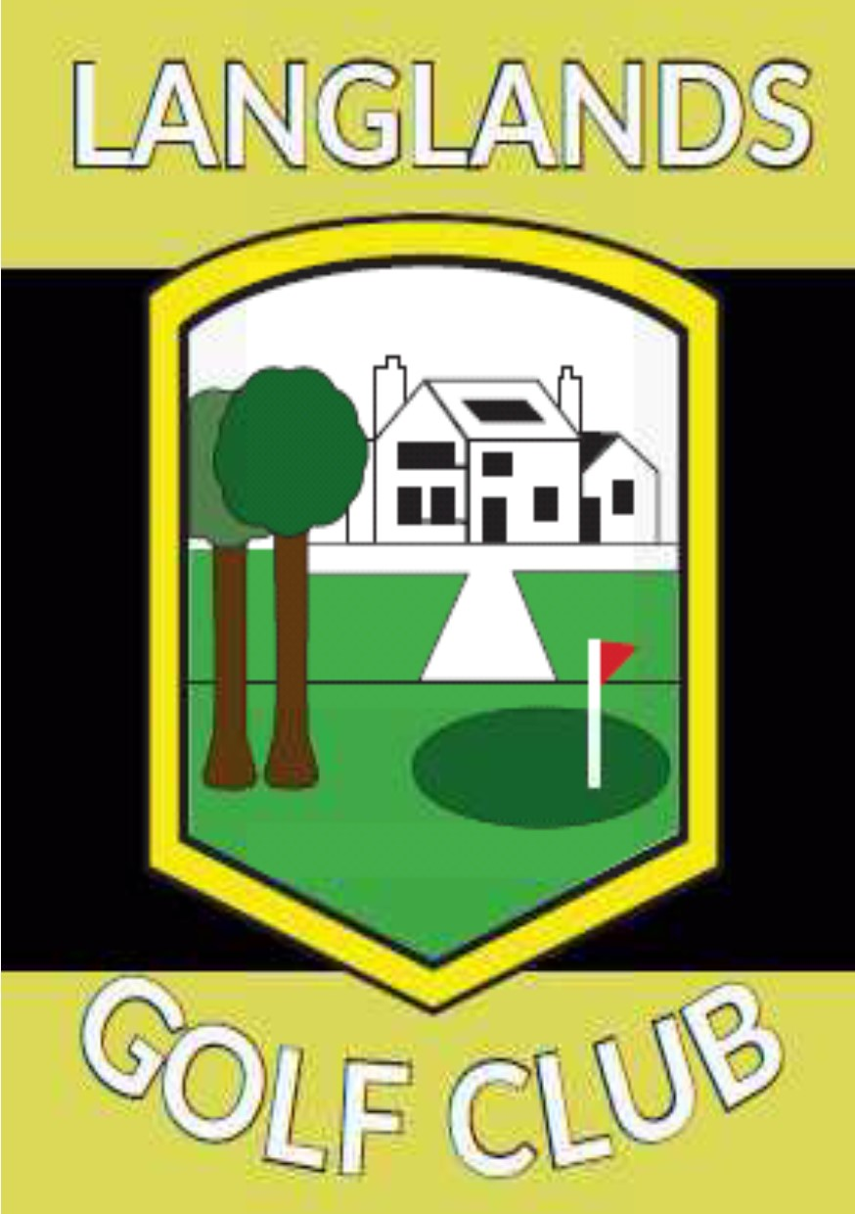

Please pay full team entry fee by bank transfer to:

Langlands Golf Club

Sort code: 80.06.64 Account number: 00532136

*Please make sure you include your name as reference*

Please return form by email to:

[langlandsgolfclub@gmail.com](mailto:langlandsgolfclub@gmail.com)

or by post to:

Match Secretary, Langlands Golf Club, Langlands Road, East Kilbride G75 9DW