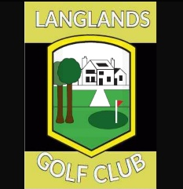
Membership Application Form – 2021

First name
Surname
Home address
Postcode
Mobile telephone number
Email address
Date of birth

Membership Category (tick as appropriate)

Ordinary Membership (21-65 on 1st March) | £170
Youth 1 (18-19 years) | £105
Youth 2 (19-20 years) | £135
Youth 3 (20-21 years) | £150
Senior Membership (65+) | £85
Junior Membership (under 18 years) | £39

A pro-rata fee may be applicable if joining during the current year. Please contact the Club Secretary to discuss.
I agree to abide by the regulations as laid down in the Constitution of Langlands Golf Club and as laid down by South Lanarkshire Leisure Limited.

Signature: |  | Date:

If you are currently a member of another golf club, please provide the following information:

Club name |  | Handicap/CDH number:

